ECE 1000 Final Report: Automatic Plant watering System

Simon Glashauser

Tennessee Technological University

Department of Electrical and Computer Engineering

Cookeville, TN, USA

[scglashaus42@tntech.edu](mailto:scglashaus42@tntech.edu), [scglasha@gmail.com](mailto:scglasha@gmail.com)

**Abstract—The Automatic Plant Watering System outlined in this report is controlled by the Raspberry Pi Pico microcontroller, the system autonomously monitors soil moisture levels using a soil moisture probe and initiates watering cycles as needed. Through the integration of a DC motor water pump, water tank, and a tubs, precise irrigation is achieved, optimizing resource utilization while promoting plant health.**

I. Introduction

Since I'm in the ECE 1000 class, this project has consisted of my final project for the class. I took one of the few options to work towards and choose this one due to time constraints. Other than this, I was also intrigued in making a self-sustaining irrigation system so long as there's a large enough water supply to allow the pump to bring more water to the plant(s).

II. Background

In the development of the automatic plant watering system, I used help from a website that my professor has provided by following the instructions that it listed. My citation section below will acknowledge this source for transparency and attribution.

ECE 1000 Fall 2024 Final Project

III. Project Description and Formulation

**Materials:**

1. Raspberry Pi Pico : Central Processing Unit for data processing
2. Soil Moisture Probe : Measures moisture levels in the soil periodically
3. Water Tank (Ceramic Mug) : Stores water used for irrigation
4. Tube : Path to move water from tank to soil
5. DC Water Pump : Move water into the tube so it can reach the soil

**Diagram:**

The diagram below depicts the usage of an Arduino instead of a Raspberry Pi.

Figure 1: *Tinker cad simulated System*

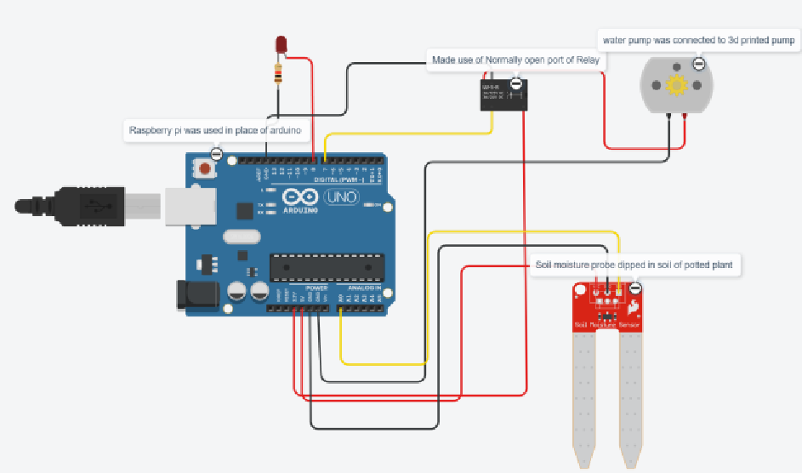

Figure 2: *Circuit Schematic of System*

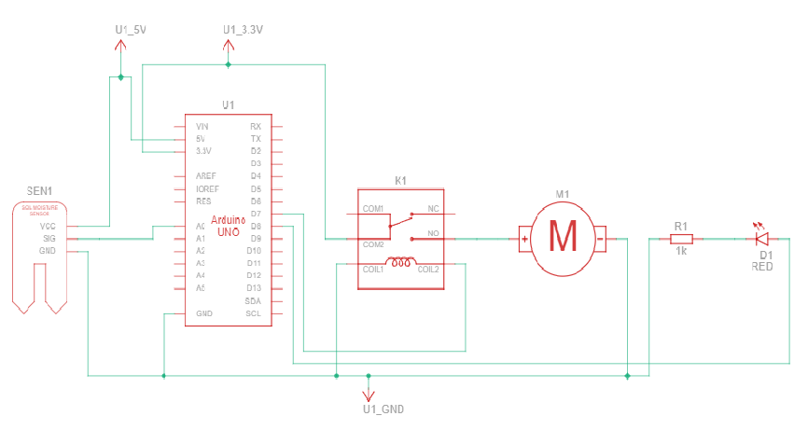

**Full System:**

The Next 2 Images will show the full system before and after the program has been executed.

Figure 3: *System On*

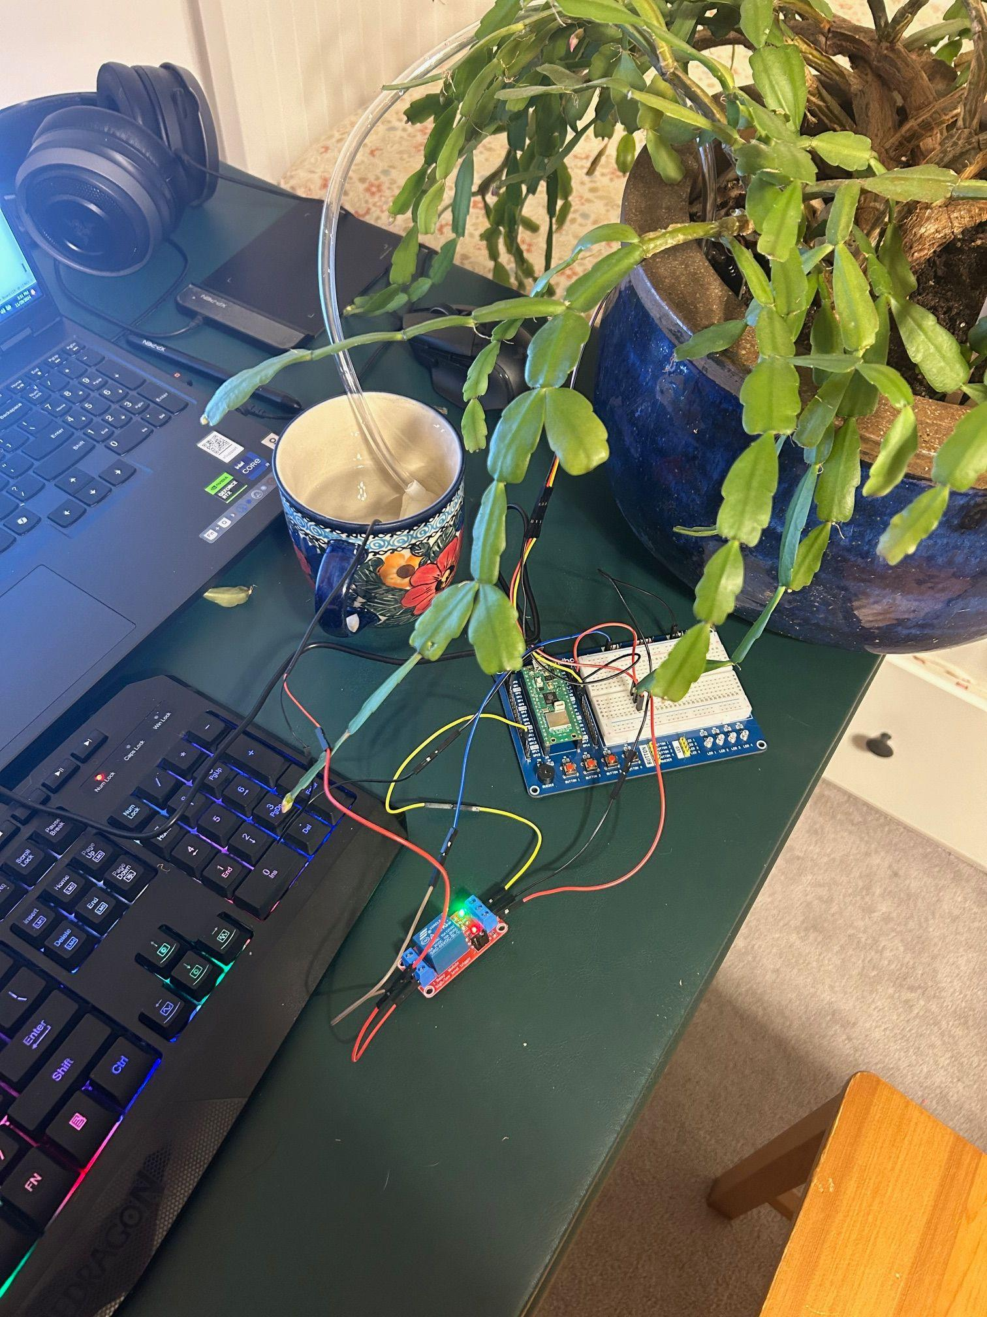

Figure 4: *System Off*

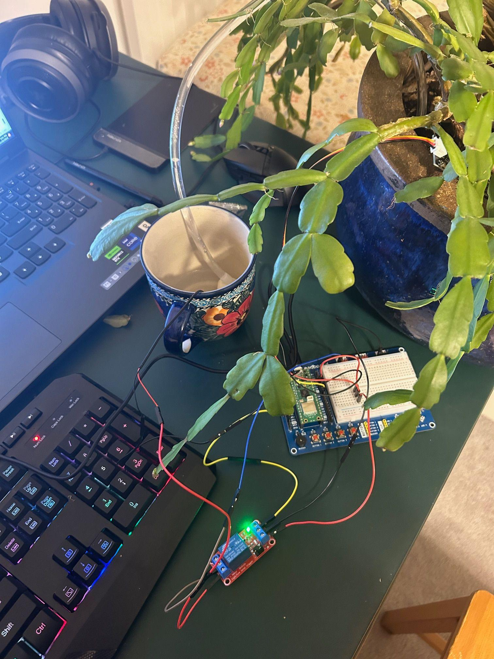

**Functionality:**

The functionality of this program is very simple. It takes the value given to it by the soil moisture sensor, which is then read to the code and if it's below a certain value the power to the switch is cut off. It is cut off instead of powered on because I needed to power the circuit, and I believe it was faulty because the High/Low Relay Module Trigger wouldn't quite finish the connection with the other circuit when power was provided to it.

Other than the slight deviance to the norm due to that issue, The project worked as intended and correctly fed water from the tank to the plant.

After being watered this way, the sensor is still active, and once the moisture level drops below its threshold, it will start pumping water again as long as there's enough left in the tank to do so.

IV. DISCUSSION AND RESULTS

The automatic plant watering system project yielded successful results, as the device effectively watered the plant according to the desired specifications. However, a minor issue

was identified regarding the calibration of the sensor as it took some trial and error to get it to work with the plant I used.

In addition to this, I think it would also be fine to replace the High/Low Relay Module Trigger, howether I don’t believe that this is necessary as the module works with the code as intended after the minor revision it underwent to work with the situation.

I was responsible for all tasks, from collecting the parts, to following the instructions, to putting the module together, to running all the tests to make sure that the module worked fully as intended.

V. Conclusion

This project has helped gain a better understanding of many of the topics that we have touched upon throughout the year, and has allowed me to get involved in base level circuit design, programming, and data logic by completing it.

It works as intended and is able to irrigate plants given that it has the correct calibration settings for the soil moisture sensor.

Through this, the project has become a potential solution for automated plant irrigation given the correct calibration settings and an ample supply of water in the water tank.

References

[1] Figures 1 & 2 were taken from Hossana Haileleul, Erdinc Ozturk, and Jack Bender’s ECE 1000 Final Project Report.

[2] Collin Chidiac. Automatic Raspberry Pico W Watering System. <https://www.instructables.com/Automatic-Raspberry-Pico-W-Watering-System/>